



PROJECT PROGRESS

AND REPORTS

**AIM**

We will be analyzing data for the Marketing team.

GlobalShala has been running

ad campaigns on Facebook for an event called Superhero U and the Marketing team needs help identifying at least one campaign to recommend discontinuing in order to cut costs. At the end , we will select one or more ad campaigns to recommend discontinuing based on your team’s analysis

# RAW DATA

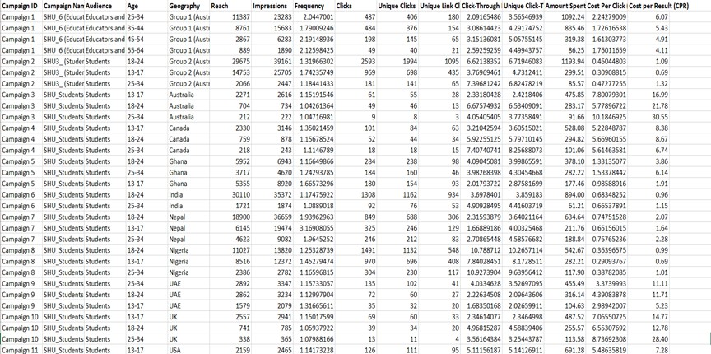





**PROCEDURE**



**STEP 1**

cleaning of data. (since no missing value was present cleaning wasn’t required)



**STEP 2**

pivot table was used using input as **campaign ID**, **unique CTR**, and cost per result for the data visualization.



**STEP 3**

we have created data visualization using clustered column charts.

Here we have the campaign ID on the **X-axis** and the average of unique CTR and cost per result on the **Y- axis**



**STEP 4**

on the chart, we have selected **campaign 3** and **campaign 10** based on the above process

**ANALYSED DATA**

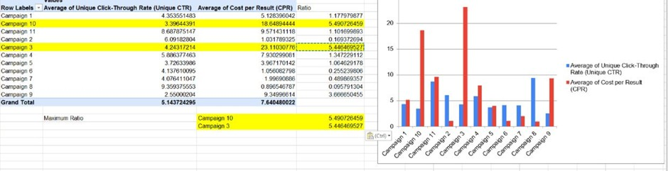

**DESCRIPTION:**

**When the ratio of unique CTR and average CPR is taken the ROI of campaign 3 and campaign 10 with a minimalistic difference is high compared to the other campaigns. Hence, it is suggested that the above- mentioned campaign must be removed.**